March 3, 2026
Sales analysis

Mahindra sells 600,000 SUVs in 11 months of FY2026, goes ahead of Tata Motors
Mahindra’s wholesales of 600,004 SUVs give it a strong lead of 34,809 units over Tata Motors’ 565,195 passenger vehicles in the past 11 months. M&M, which had lost out to Tata in FY2025 by 17,758 units, is set to be the new No. 2 in FY2026 while Tata will be the new No. 3 ahead of Hyundai.

By Ajit Dalvi
In the battle for supremacy for the No. 2 position in the Indian passenger vehicle market in the current fiscal year, Mahindra & Mahindra (M&M) has taken the lead, despite having being outsold in January-February by a resurgent Tata Motors.
At the end of January 2026, with cumulative 10-month sales of 539,986 units, M&M needed to sell 60,014 units in February to achieve the 600,000 milestone. The SUV maker sold four more – 60,018 units – taking its 11-month total to 600,004 units, up 19% YoY (April 2024-February 2025: 503,439 units). This includes its highest-ever monthly sales of 71,624 units in October 2025 and two straight months of 60,000-plus sales this January and February.

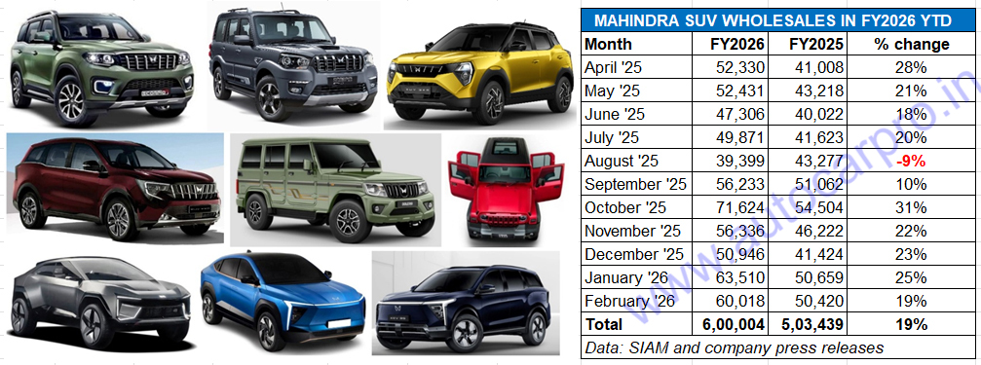
M&M, which clocked record wholesales of 625,603 units in CY2025, is set to register a new high between 650,000-670,000 SUVs which will give it the No. 2 PV rank in FY2026.

This stellar performance comes on the back of the company registering record calendar year sales of 625,603 SUVs in CY2025, up 18% YoY (CY2024: 528,460 units). M&M’s show of strength in CY2025 saw it rise two ranks in the passenger vehicle segment to become the new No. 2 OEM after Maruti Suzuki (1.80 million PVs). As a result of Mahindra’s record sales, Tata Motors (578,771 units) lost its No. 2 PV ranking in CY2024 to be ranked third in CY2025, pipping fourth-ranked Hyundai Motor India (571,878 units) by 6,893 units.
FY2026 will see M&M repeat its CY2025 ranking to become the No. 2 PV OEM for the first time in a fiscal. In FY2025, the fourth-ranked M&M (551,487 SUVs) had lost out to Tata Motors (569,245 units) by just 17,758 units. Hyundai Motor India (598,666 units) was the No. 2 OEM behind the unassailable PV market leader Maruti Suzuki (1.76 million units).
In FY2026 YTD, M&M has outsold Tata Motors in six out of the past 11 months (April-July 2025, October and December 2025) while Tata got the better of M&M for five months (August-September 2025, November 2025, January and February 2026. M&M’s vigorous growth is the result of surging demand for some of its models, particularly the Scorpio twins, Thar Roxx, 3XO, the Born Electric SUV portfolio (XEV 9e and BE 6) which now stands expanded with the new XEV 9S, as well as the recently launched XUV 7XO.
In the first 10 months of FY2026, the EV share of M&M’s 539,986 SUVs was 7.52% comprising 40,626 units BE 6 and XEV 9e (37,402 units), XEV 9S (1,103 units) and XUV400 (381 units). The Scorpio twins (149,557 units) are the best-selling product, followed by the Thar Roxx-Thar (104,342 units), Bolero and Bolero Neo (90,485 units), 3XO: 85,505 units, XUV700 (58,108 units), and the recently launched XUV7XO (10,982 units).
Given the current robust growth trajectory and the fact that M&M has averaged monthly sales of 58,158 units between December 2025 and February 2026, M&M is well placed to achieve record 650,000-plus sales in FY2026. This will constitute an 18% YoY increase (FY2025: 551,487 units) and mark the first time that M&M will surpass 650,000 sales in a single fiscal year.
TATA MOTORS TO ACHIEVE 600,000 SALES FOR THE FIRST TIME
Tata Motors, which has a nine-model portfolio comprising six SUVs (Nexon, Punch, Curvv, Harrier, Safari and Sierra), two hatchbacks (Altroz and Tiago) and one sedan (Tigor), is headed towards achieving its highest fiscal year sales. Eleven months into FY2026, the company has registered wholesales of 565,195 units, up 13% YoY (April 2024-February 2025: 501,969 units). It is currently just 4,050 units away from its FY2025 score (569,245 units, down 2% YoY) and 17,720 units shy of its highest fiscal year sales of 582,915 units in FY2024.

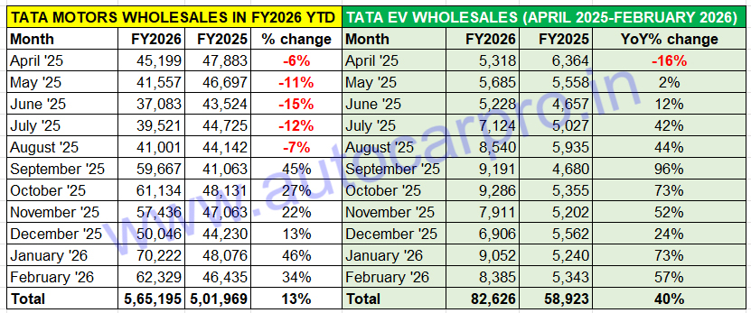Tata Motors, which has already achieved its highest EV wholesales, will drive past the 600,000 sales milestone for the first time in FY2026 and in the process take the No. 3 slot in the overall PV market.
Tata Motors’ numbers for FY2026 would have been better but for the sustained five-month sales decline from April to August 2025 (see data table above). Demand bounced back from September as a result of the sizeable price reductions driven by GST 2.0 as well as a new model and variant introductions.
Bolstered by its highest monthly sales in January 2026 (70,222 units, up 46%), followed by an equally robust February (62,329 units, up 34%), Tata Motors will achieve the 600,000-unit milestone for the first time in a 12-month period and should wrap up FY2026 with estimated wholesales between 635,000 to 640,000 units. In calendar year 2025, Tata Motors fell 21,229 units short of the 600,000 milestone with total passenger vehicle sales of 578,771 units (up 3%) including 81,125 EVs (up 18%).
Driving the charge in FY2026 are Tata Motors’ top two models – the Nexon and Punch compact SUVs – as well as growing demand for the recently launched Sierra SUV, petrol variants of the Harrier and Safari SUVs. Of the 502,866 PVs it sold in the first 10 months of FY2026 (April 2025-January 2026), the Nexon and Punch compact SUVs (321,069 units) account for a 64% share. The third and fourth best-selling models are the Tiago (68,876 units) and Altroz (33,746 units), followed by the Harrier (26,992 units), Curvv (18,842 units), Safari (16,328 units), Tigor (9,719 unit) and the just-launched Tata Sierra (7,294 units).
Tata Motors, which has the largest EV portfolio in the form of the Nexon EV, Punch EV, Tiago EV, Curvv EV and Harrier EV, also has the highest EV penetration level amongst mainstream PV OEMs. I the first 11 months of FY2026, with record dispatches of 82,626 electric cars and SUVs, up 40% YoY (April 2024-February 2025: 58,923 units), the e-PV market leader has a current EV penetration level of 15%, up three percentage points from the 12% it had in the year-ago period.
In the current fiscal, Tata Motors has already achieved its highest-ever fiscal-year EV sales, having beaten the previous best – FY2024’s 73,833 units. EV sales in FY2025 (64,276 units, down 13% YoY) had dragged down overall PV sales for the company.
As a result of the surge in demand for Tata EVs, the company’s EV penetration level in the current fiscal has risen to 15%, up three percentage points from the 12% a year ago. With March 2026 sales still to be counted, expect Tata EV sales to surpass 90,000 units and likely close in on the 100,000-unit mark in FY2026.
In FY2025, Tata Motors (569,245 PVs) was India’s PV OEM No. 3 after Maruti Suzuki (1.76 million PVs) and Hyundai India (598,666 PVs) and was ahead of Mahindra & Mahindra (551,487 SUVs) by 17,758 units. Eleven months into FY2026, Tata Motors (565,195 units) is still ranked third after Maruti Suzuki (1,656,910 units, up 3%) and Mahindra (600,004 units, up 19%) and well ahead of Hyundai Motor India (529,842 units, down 3%), Toyota Kirloskar Motor (331,804 units, up 18%) and Kia India (259,923 units, up 13%).

M&M AND TATA PUSH HYUNDAI DOWN TO FOURTH RANK
In India’s ultra-competitive SUV and car marketplace, which received a booster shot in the form of GST 2.0, FY2026 will see changes in the podium positions other than that of the market leader Maruti Suzuki.
Longstanding No. 2 Hyundai Motor India, which has sold 529,842 units in the past 11 months, is expected to wrap up this fiscal with estimated sales of around 585,000 units, well below its highest sales of 614,721 units in FY2024, leaving the door open for a new player to take that podium slot.
With one month left to be counted in FY2026, M&M has a strong lead of 34,809 units over Tata Motors. While both automakers are expected to register handsome sales in the fiscal-year-ending month, suffice it to say that Mahindra, which had lost out to Tata Motors in FY2025 by 17,758 units, will become the No. 2 passenger vehicle OEM for the first time in FY2026. What’s common to both these players is they are riding the strong wave of demand for their SUVs, both compact and midsize models. Of the top six OEMs, four including M&M and Tata will achieve their highest-ever fiscal year sales in FY2026. Keep watching this space for the latest in number-crunching news and analysis.

ALSO READ: Tata Motors, JSW MG, M&M command 86% of e-PV sales in February, Maruti sells 214 e-Vitaras

