**Tata Curvv sells over 44,000 units in first year since launch**

*Launched on August 7, 2024, the Tata Curvv SUV-coupé with electric, petrol and diesel powerplants completes a year in the domestic market. The 44,246 units account for an 8% share of Tata Motors’ passenger vehicle wholesales and a 10% share of the 461,378 SUVs sold in the past 12 months.*

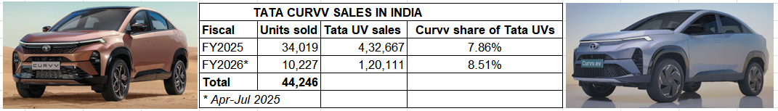

The Tata Curvv SUV-coupé, the eighth model in Tata Motors’ passenger vehicle portfolio and its fifth utility vehicle, has completed a year in the domestic market. Launched in its [**electric avatar on August 7**](https://www.autocarpro.in/news/tata-curvv-ev-priced-at-rs-1749-lakh-121921) and [**petrol- and diesel-engined variants on September 2**](https://www.autocarpro.in/news/tata-motors-launches-curvv-at-introductory-price-of-rs-10-lakh--122341), 2024, the Tata Curvv has sold an estimated 44,246 units, which makes for an 8.28% share of Tata Motors’ passenger vehicle sales of 534,116 units and a 9.58% share of the 461,378 utility vehicles sold between August 2024 and end-July 2025.

In FY2025’s last eight months, the Curvv sold 34,019 units and contributed 7.86% to Tata Motors’ UV dispatches of 432,667 units. The’s Currv highest monthly sales to date were in festive October 2024 (5,351 units), which remains its best monthly score in its 12 months of market presence.

In the current fiscal’s first four months, with 10,227 units and 8.51% UV share, the Curvv is the company’s third highest-selling SUV after the Nexon (52,980 units, 44% UV share) and the Punch (46,860 units, 39% UV share), and ahead of the Harrier (5,381 units, 4.48% UV share) and the Safari (4,614 units, 3.84% UV share). Its highest monthly sale in FY2026 (April-July 2025) has been the 3,149 units in April 2025.

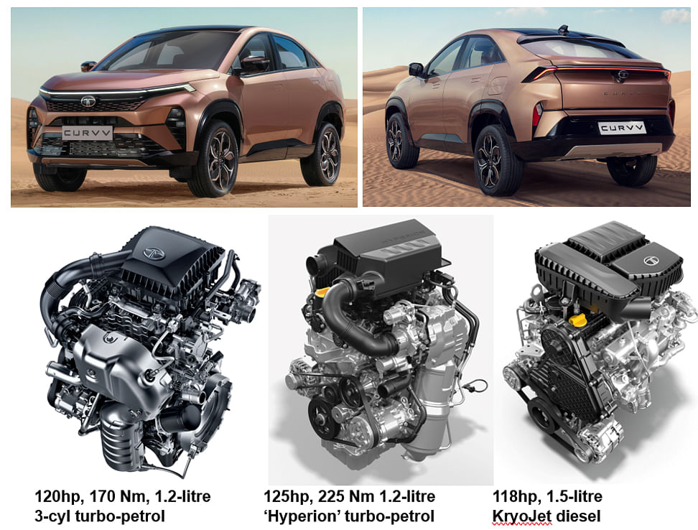 *The ICE Curvv is available with three options – two petrol and one diesel.*

The ICE Curvv, with has all of 50 variants on sale – 24 petrol, 18 diesel and 8 electric has a starting on-road price of Rs 12.20 lakh (on-road Mumbai) for the base 1.2 Smart petrol variant and goes up to Rs 23.50 lakh for the top-end 1.5 Accomplished+ A Dark DCT diesel variant. The Curvv EV’s pricing starts at Rs 18.95 lakh and goes upward to Rs 23.55 lakh (on-road Mumbai).

This grown-up sibling of the Tata Nexon goes head-to-head with the Citroen Basalt (which has sold an estimated 553 units in April-July 2025 and a total of 2,018 units since launch), and aims to disrupt the midsize SUV segment as an alternative to the Hyundai Creta, Maruti Grand Vitara, Kia Seltos, Toyota Hyryder, MG Astor Honda Elevate, Skoda Kushaq and the Volkswagen Taigun as its main rivals.

Developed on Tata Motors’ new ATLAS platform, the ICE Curvv is available with three options – a 120hp, 170 Nm, 1.2-litre, three-cylinder diesel engine which delivers 118hp, and a [**new 1.2-litre DI turbo-petrol ‘Hyperion’ engine which produces 125hp and 225 Nm**](https://www.autocarpro.in/feature/tata-curvv-targets-mid-size-suv-market-with-advanced-12-gdi-powertrain-123645). All three powerplants get a six-speed manual transmission as standard fitment, while a seven-speed dual-clutch automatic is offered as an option.

The Tata Curvv’ interiors, barring minuscule changes like a dual-tone burgundy-and-black theme, are from siblings Nexon and Nexon EV – the dashboard design and centre console are the same, while the four-spoke steering is from the Harrier and Safari SUVs.

The Curvv does well on the feature front with a segment-first powered tailgate with gesture control, 18-inch alloy wheels, flush door handles, a 12.3-inch touchscreen infotainment system, a fully digital driver’s display, a panoramic sunroof, reclining rear seat, and ventilated front seats. The Curvv’s safety suite consists of six airbags, Level 2 ADAS, ESC, disc brakes on all four wheels, TPMS, a 360-degree camera, an electronic parking brake with auto-hold, and more.

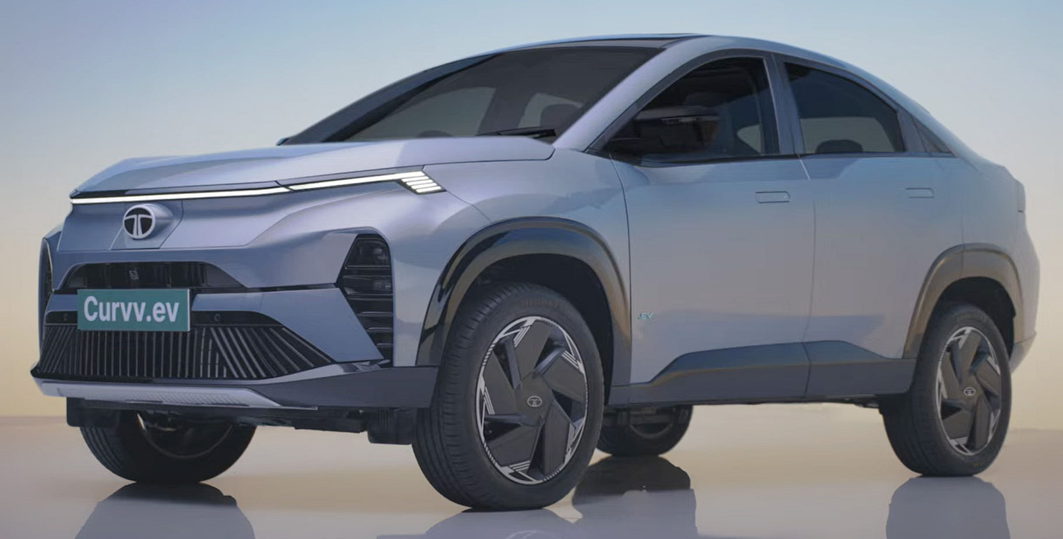

Since the Curvv EV’s launch in August 2024, Tata Motors has sold 66,025 EVs in the past 12 months. However, the Curvv EV’s specific share of Tata EV wholesales is not available.

The Curvv EV has two battery pack options: a 40.5kWh unit for the Creative, Accomplished and Accomplished+ variants, and a 55kWh one for the Accomplished, Accomplished+ S, Empowered+, and Empowered+ A variants. While the former has an MIDC range of 502km, the latter can travel 585km on a single charge. Tata Motors claims that its own C75 standard of testing (which is closer to a real-world figure) will see the long-range model go 400-425km on a single charge, while the 45kWh Curvv EV has a range of 330-350km. For reference, the MG ZS EV's 50.3kWh unit has an ARAI-rated 461km.

All variants get a 167hp electric motor mounted on the front axle, enabling the Curvv EV to accelerate from 0-100kph in 8.6 seconds and hit a top speed of 160kph. Tata claims that the battery can get up to 150km worth of charge in just 15 minutes, and 10-80% charge in 40 minutes, on a 70kW charger. The iRA app is said to have an integrated charge point and the model comes with vehicle-to-load (V2L) and vehicle to vehicle (V2V) charging capabilities.   
(With inputs from*Autocar India*)

Tata UV sales   
August 2024-March 2025: 298,018

Curvv share: 9.58%

April-July 2025: 163,360  
Total: 461,378 PVs

PV sales in past 12: 534,116 PVs  
Curvv share: 8.28%