March 2, 2026
Sales Analysis

Tata Motors, JSW MG, M&M command 86% of e-PV sales in February, Maruti sells 214 e-Vitaras

Or

Tata Motors holds onto 41% share of e-PV market in February, Maruti sells 214 e-Vitaras
With 5,558 units, Tata Motors had a 41% share of the 13,669 zero-emission passenger vehicles sold last month while JSW MG Motor and Mahindra together accounted for 45 percent. Maruti Suzuki, which commenced sale of its first EV, sold 214 units for a 1.56% share of the e-PV market.

By Ajit Dalvi
Retail sales of electric passenger vehicles in February didn’t really march into March. A total of 13,669 zero-emission vehicles were sold last month, up 44% YoY (February 2025: 9,479 units). While this does reflect strong YoY growth, February 2026 sales, however, are down 28% month-on-month (January 2026: 18,993 units) and are the lowest since June 2025. Nevertheless, cumulative 11-month sales have crossed the 175,000 units mark and at 175,364 units are up 84% YoY (April 2024-February 2025: 95,101 units). In CY2025, India e-PV Inc had registered total retail sales of 177,394 units.

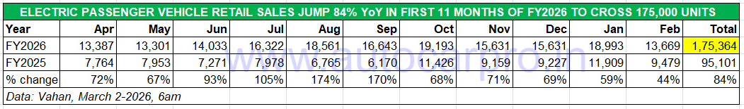
With the FY2026-ending March still to be counted, will demand for electric cars and SUVS see a surge and enable the industry to surpass 200,000 units for the first time in a fiscal year?

Market leader Tata Motors delivered 5,558 electric SUVs and cars to its customers last month, up 39% YoY (February 2025: 4,002 units). This gives it an e-PV share of 41%, slightly down on the 43% it had in January 2026 when it accounted for 8,246 units from the record 18,993 e-PVs sold in India – both marking a new monthly high for the company and India e-PV Inc.
In the first 11 months of FY2026, Tata Motors has sold 69,765 e-PVs, which constitutes a 32% YoY increase (April 2024-February 2025: 52,717 units). While the Harrier EV continues to draw new buyers in addition to existing demand for the Nexon EV and Tiago EV, expect the new Punch EV launched on February 20, 2026 at Rs 969,000 to accelerate sales from March 2026 onwards. Of the company’s six-model EV portfolio, the Curvv EV coupe-SUV is yet to achieve sustained growth.
JSW MG Motor India, the No. 2 OEM which has been the lead player in reducing Tata Motors’ once- commanding 60% market share to a little above 40% now, sold 3,310 EVs last month, down 5% YoY (February 2025: 3,489 units). This performance gives the company a 24% market share and takes its 11-month total to 47,567 units, up 81% YoY (Apil 2024-February 2025: 26,344 units). The game-changing Windsor, which also introduced the BaaS option to the e-PV market, continues to be the growth driver for JSW MG Motor which has recently expanded its portfolio with the M9 MPV and Cyberster roadster joining the Comet EV and ZS EV.
Third-ranked EV OEM Mahindra & Mahindra delivered 2,913 e-SUVs last month, up 473% YoY on a low year-ago base (February 2025: 508 e-SUVs). This gives it a 21% market share for last month and takes its cumulative 11-month retails to 36,673 units. While the two Born Electric SUVs – BE 6 and XEV 9e – launched in early 2025 remain the key growth drivers, demand would have come from the recently launched XEV 9S, M&M’s first three-row, born-electric SUV based on the modular INGLO skateboard platform. The XEV 9S, which has battery options spanning 59 kWh, 70 kWh and 79 kWh, slots above the stylish XEV 9e and the radical BE 6 SUVs, both of which are two-row EVs.
Vinfast India delivered 384 units of its two e-SUVs last month, the same number as in December 2025. This gives the Vietnamese EV maker a 3% share in only its fifth month of retail sales and the No. 4 rank amongst 17 players. Between October 2025 and February 2026, Vinfast has sold 1,660 units of the locally assembled VF6 and VF7 e-SUVs with the highest monthly sales coming in January 2026 (440 units). With both these e-SUVs receiving a five-star Bharat NCAP crash test rating, expect monthly numbers to further grow this year albeit the competition also continues to increase. Meanwhile, recognising the potential of the growing market for electric MPVs and the demand for the Kia Carens Clavis EV and the BYD eMax 7, Vinfast India has confirmed plans to launch its third premium EV – the seven-seater Limo Green electric MPV – soon.
BYD India registered new EV sales of 306 units last month, up 10% YoY (February 2025: 278 units), to go ahead of Hyundai Motor India by two units. The Indian arm of the Chinese EV major, which sells the Atto 3 SUV, Seal sedan, eMax 7 MPV and the Sealion 7 SUV, has increased prices of the premium Sealion 7 from January 1.
Amid the intense competition in the e-SUV market, the sixth-ranked Hyundai Motor India is having a tough time what with tepid demand for its main product – the Creta EV – and the Ioniq 5. The company sold 304 units in February 2026, down by a substantial 61% YoY (February 2025: 775 units). Cumulative 11-month sales are 5,371 units for Hyundai.
Kia India sold 295 electric utility vehicles last month, up 1241% on a low year-ago base of just 22 units. Following the launch of the mass-market Carens Clavis EV MPV, which joined the far more expensive EV6 and EV9 imported as CBUs, Kia has seen its monthly numbers improve. However, February 2026 sales are the lowest in the past seven months after August (465 units), September (530 units), October (681 units), November (480 units), December (329 units) and January (317 units).
Luxury e-PV market leader BMW India takes No. 8 position with sales of 245 units which marks slower 3% YoY growth (February 2025: 239 units) compared to the 334 units it sold in January 2026. Nevertheless, this German carmaker has been on a roll in the past year. In the first 11 months of FY2026, it has already sold 3,081 units, up 136% YoY (April 2024-February 2025: 1,305 units). Expect BMW India, which clocked sales of 3,207 units in CY2025, to wrap up FY2026 with total retails of 3,400 units. In January this year, the EV maker delivered the 1,000th unit of its flagship electric sedan, the BMW i7 which sits at the top of its India line-up.
Maruti Suzuki, which had unveiled its first EV – the e-Vitara SUV – in January and commenced sales in mid-February, sold 214 units last month as per Vahan retail stats. This gives the company a 1.56% share of total e-PV sales in February 2026. The Maruti e-Vitara battery pack options include a 49kWh and a 61kWh choice with a claimed range of 543km and 440km, respectively. The smaller battery is mated with a 144hp electric motor, while the larger battery pack is paired with a 174hp motor. The e Vitara is offered with only a front-wheel-drive (FWD) setup, although it gets an all-wheel-drive AWD option in the overseas markets. The Maruti e-SUV is priced from Rs 15.99 lakh to Rs 19.79 lakh (with the BaaS option, prices drop to Rs 10.99 lakh for the Delta 49 kWh variant, Rs 11.99 lakh for the mid-spec Zeta variant, and Rs 14.29 lakh for the fully loaded Alpha 61 kWh variant, excluding the battery subscription fee.
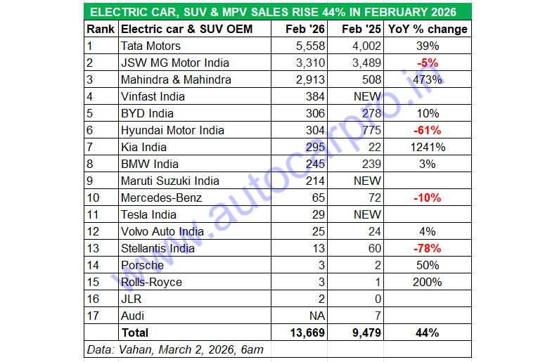

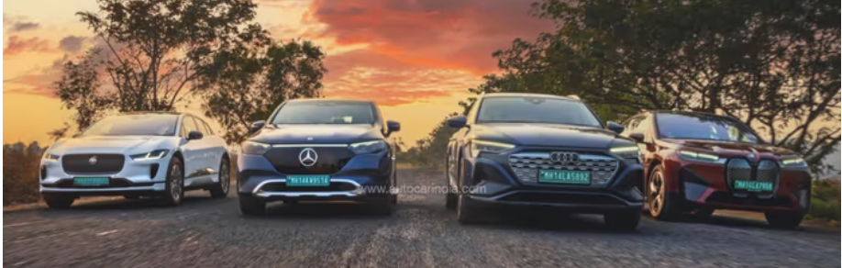

LUXURY ELECTRIC VEHICLE MAKERS SELL 372 UNITS IN FEBRUARY, UP 8%
Demand for luxury zero-emission cars, SUVs and MPVs was tepid last month. Compared to the 482 units sold in January 2026, February sales from the eight OEMs at 372 units (up 8% YoY: February 2025: 345 units) were down 23% month on month.
Market leader BMW India (as mentioned earlier) tops the table with 245 units, which gives it a commanding 66% share of this e-PV category. Mercedes-Benz India sold 65 zero-emission PVs last month, down 10% on the 72 units it sold in February 2025, for a 17% market share in February 2026.
Tesla India sold 29 units of the Model Y e-SUV last month, which gives the American EV maker an 8% share of the luxury e-PV market. The Model Y, imported as a CBU, is currently available in India starting at Rs 59,89,000, with home charging support included for customers. This takes six-month sales since market entry in September 2025 to 293 units.
Volvo India sold 25 zero-emission cars and SUVs, one more than it did a year ago, Rolls-Royce sold three units of its all-electric model – the Spectre – which is literally the Rolls-Royce of EVs priced from Rs 7.50 crore through to Rs 9.50 crore for the Spectre Black Badge. In the past 11 months of FY2026, 14 such uber-luxurious Spectres have been sold.

ALSO READ: Tata Motors Well Set to Sell 600,000 Cars and SUVs, 100,000 EVs in FY2026
Electric car and SUV sales in India hit new high in CY2025: 176,500 units
Maharashtra Is No. 1 buyer of electric cars and SUVs in CY2025

